**Rogue Society Writeup**:

First part:

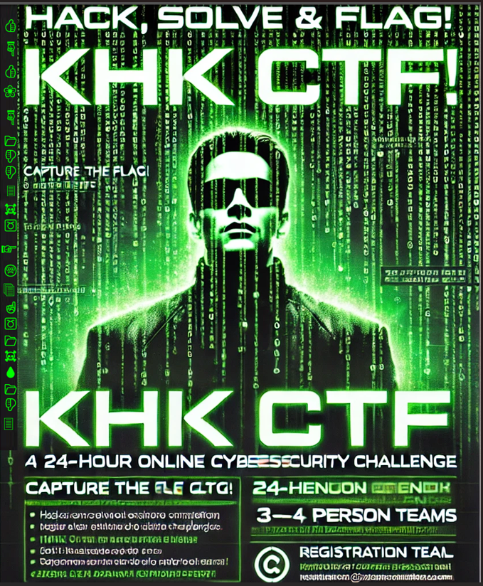

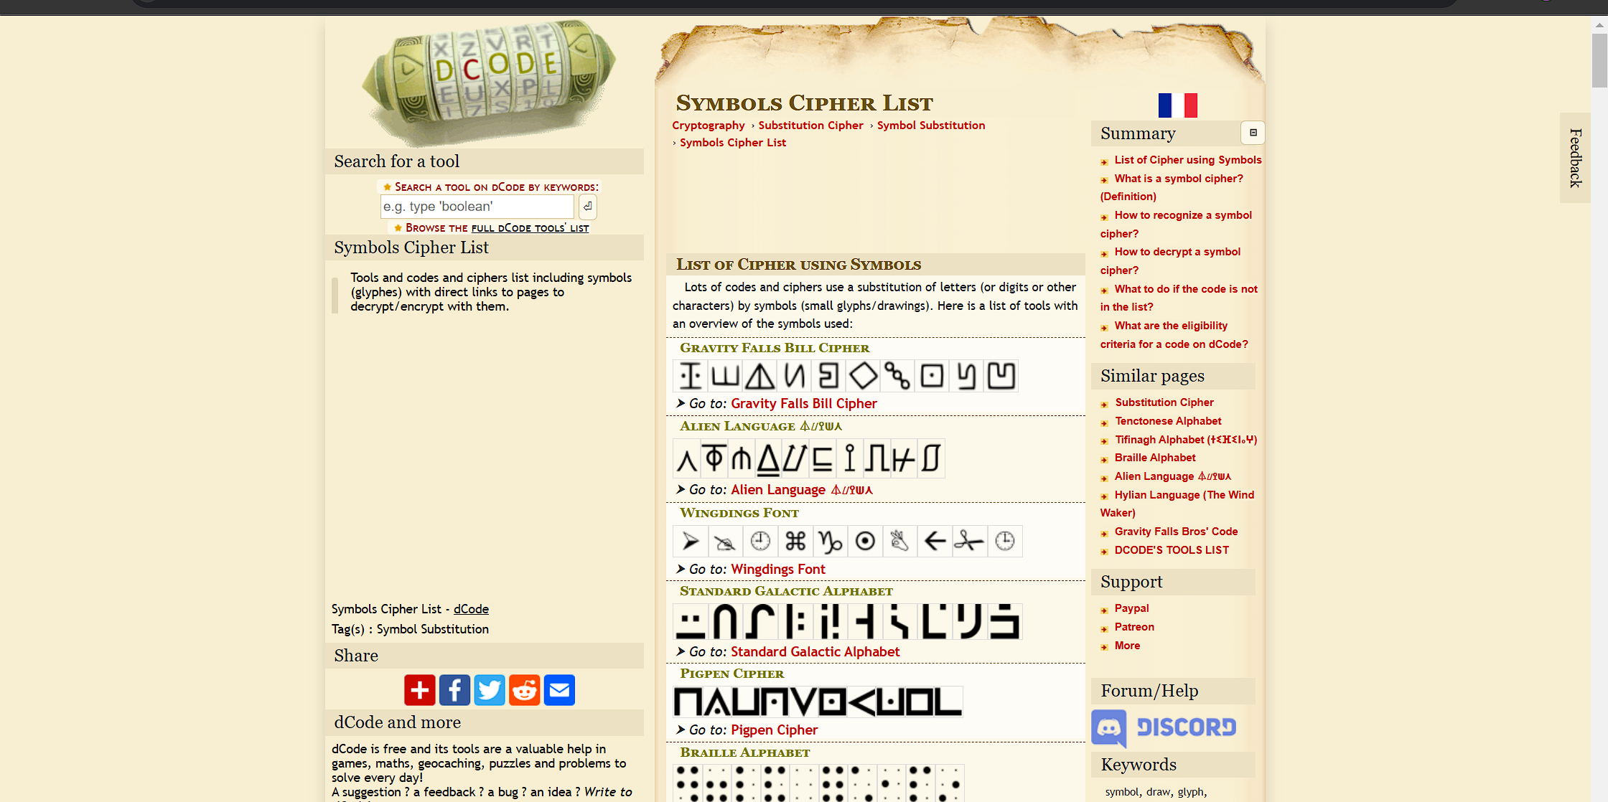

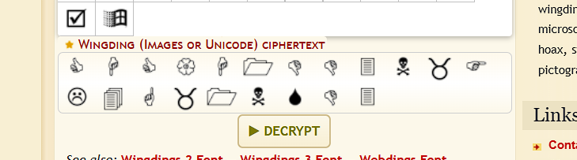

**Second part:**

Extract 2 images from poster.png using binwalk, the secret.jpg is a rabbithole so we will ignore that.

If we image search the logo, after a lot of khwaari we can come across articles on piet programming language

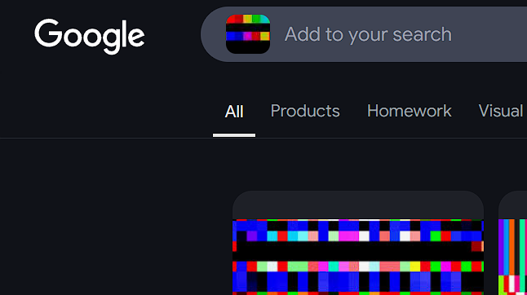

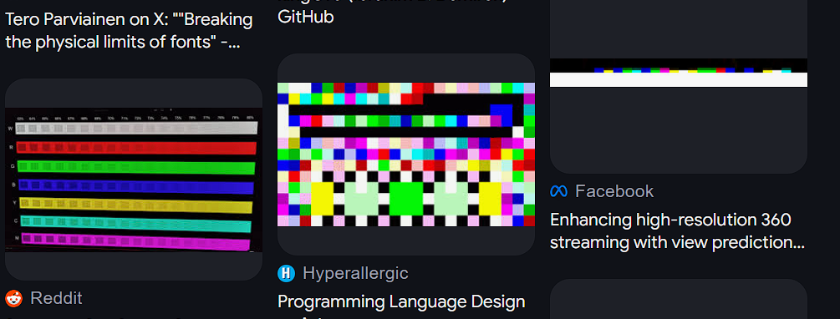

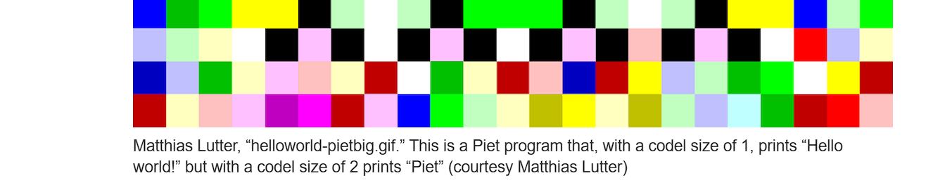

Searching up the image leads us to the piet language.  
  
  
**hint 1:**

**"Hello Pieter! did u control the stack"**  
reference to the language used and the fact it uses the stack.

If u search up any CTF chall related to this .

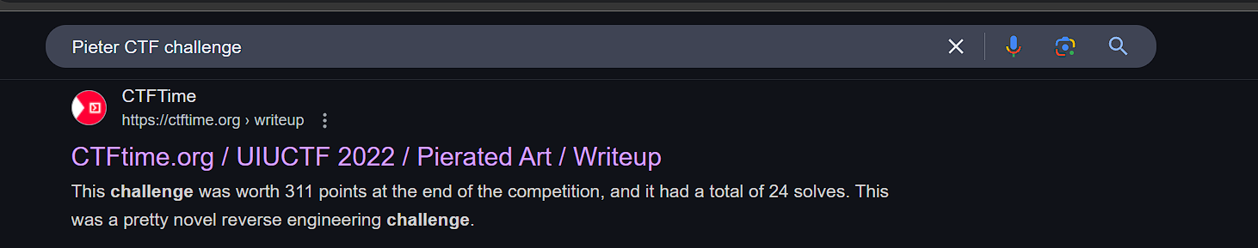you’ll find a challenge with same solution.

**Hint2:**

**"If u look at the logo, esoteric problems require esoteric solutions"**

Look up esoteric languages and you’ll find Piet in the list. Or ask GPT

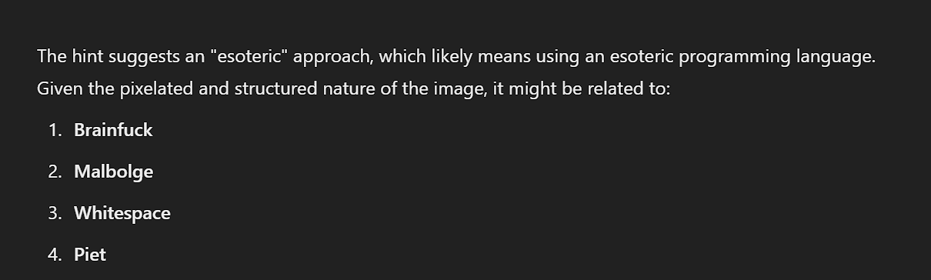

Then download the interpreter and get the flag, or do it online

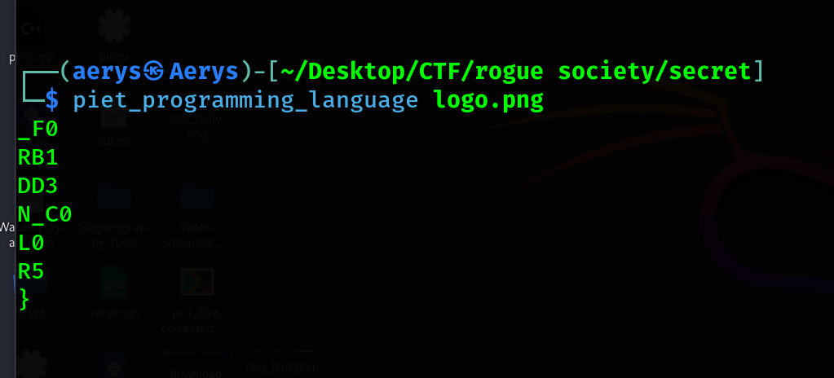

_F0RB1DD3N_C0L0R5}

**Full flag**

**CHC{H1DD3N_FL4G_1NSD3_F0RB1DD3N_C0L0R5}**